Amrita School Of Engineering

B. Tech CSE-AI



19AIE104

INTRODUCTION TO ELECTRICAL ENGINEERING

**SEMESTER -1 PROJECT**

**VOLTAGE COMPARATOR USING OP AMP**

(UNDER THE GUIDANCE OF DR.V. Sowmya)

**OBJECTIVE:-**

To learn about **operational amplifier** or **op amp** , that is designed with certain characteristics (high input resistance, low output resistance, and a large differential gain) that make it a nearly ideal amplifier and useful building-block in many circuit applications. OP AMP is almost like an ideal amplifier.

**MATERIALS REQUIRED:-**

* **simulation platform [ Falstad/Matlab]**

**DESCRIPTION OF COMPONENTS:**

**FAlSTAD:**

This is an electronic circuit simulator.  When the applet starts up you will see an animated schematic of a simple LRC circuit. The green color indicates positive voltage.  The gray color indicates ground.  A red color indicates negative voltage.  The moving yellow dots indicate current.

To turn a switch on or off, just click on it.  If you move the mouse over any component of the circuit, you will see a short description of that component and its current state in the lower right corner of the window.

**MATLAB**

MATLAB® combines a desktop environment tuned for iterative analysis and design processes with a programming language that expresses matrix and array mathematics directly. It includes the Live Editor for creating scripts that combine code, output, and formatted text in an executable notebook.

**CIRCUIT DIAGRAM:-**

**For using op amp as comparators:**

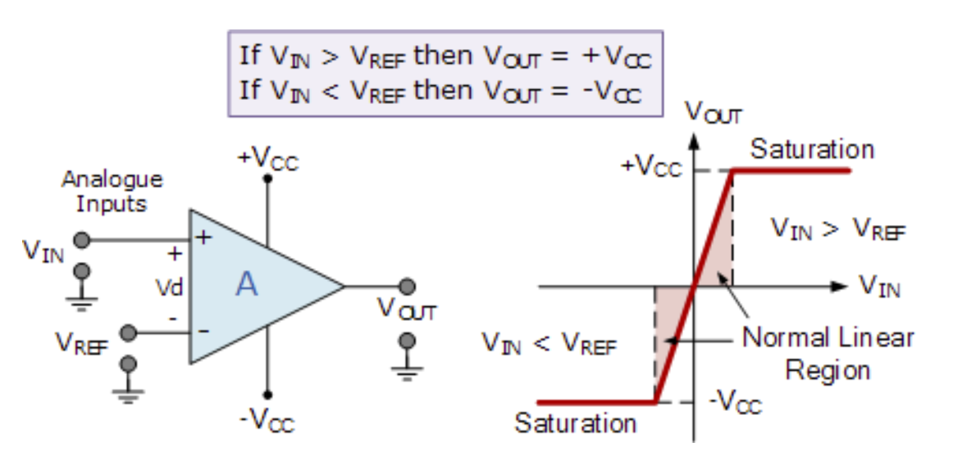

**BASIC CONCEPT:-**

**Op amp :**

* An operational amplifier is an integrated circuit that can amplify weak electric signals. An operational amplifier has two input pins and one output pin. Its basic role is to amplify and output the voltage difference between the two input pins.

**Op amp as a comparator :**

The **Op-amp comparator** compares one analogue voltage level with another analogue voltage level, or some present reference voltage, VREF and produces an output signal based on this voltage comparison. In other words, the op-amp voltage comparator compares the magnitudes of two voltage inputs and determines which is the largest of the two.

* Voltage comparators either use positive feedback or no feedback at all (open-loop mode) to switch its output between two saturated states (+Vcc ,-Vcc), because in the open-loop mode the amplifiers voltage gain is basically equal to AVO.
* Then due to this high open loop gain, the output from the comparator swings either fully to its positive supply rail, +Vcc or fully to its negative supply rail, -Vcc on the application of varying input signal

## Non inverting amplifier/ Positive Voltage Comparator:-

* It is an op-amp circuit which gives an amplified signal as output. In this electronic circuit design the signal is applied to the non-inverting input of the op-amp.

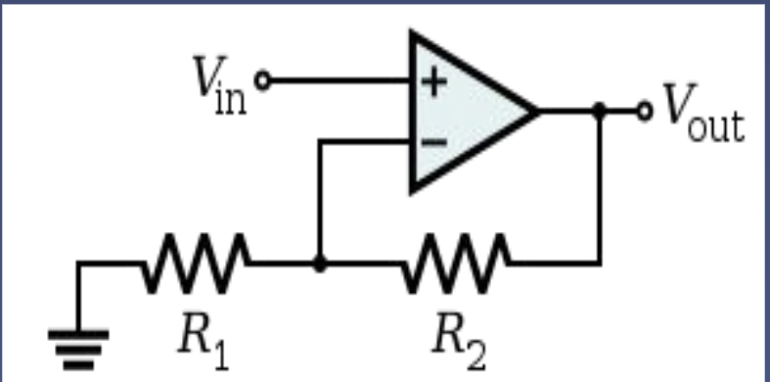

* In this way the signal at the output is not inverted when compared to the input. The output signal is in phase with the applied input signal.
* However the feedback is taken from the output of the op-amp via a resistor to the **inverting input** [uses a negative feedback connection] of the operational amplifier where another resistor is taken to ground.
* it is the value of these two resistors that govern the gain of the operational amplifier circuit as they determine the level of feedback.
* Closed loop op amp
* 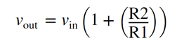 Here amplification factor is .

## Inverting amplifier/ Negative Voltage Comparator:-

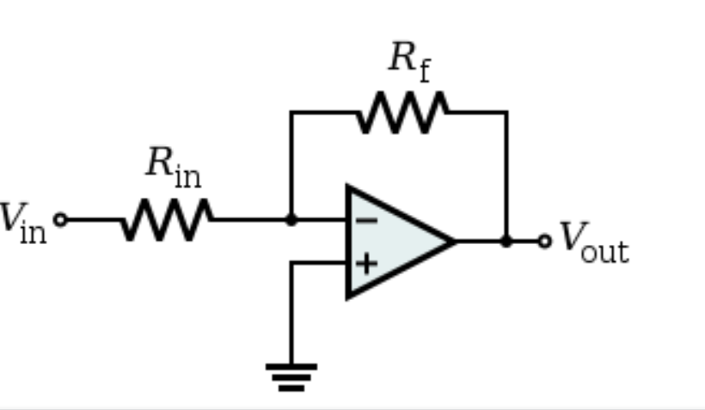 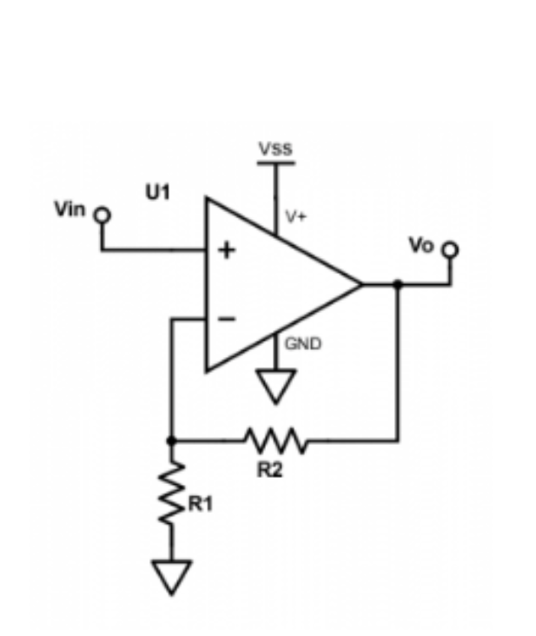

* An inverting amplifier (also known as an inverting operational amplifier or an inverting op-amp) is a type of operational amplifier circuit which produces an output which is out of phase with respect to its input by 180o.
* This means that if the input pulse is positive, then the output pulse will be negative and vice versa
* Closed loop op amp
* Here we apply the input signal to the inverting terminal of the op-amp via the resistor Ri. We connect the non-inverting terminal to ground. Further, we provide the feedback necessary to stabilize the circuit, and hence to control the output, through a feedback resistor Rf.
* 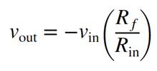 . where Amplification factor is 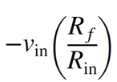
* check the negative sign in amplification factor it is because the output is inverted therefore a notation of negative sign is given

**Op-amp comparator** : It compares one analogue voltage level with another analogue voltage level, or some preset reference voltage, VREF and produces an output signal based on this voltage comparison. In other words, the op-amp voltage comparator compares the magnitudes of two voltage inputs and determines which is the largest of the two.

* operational amplifier can be used with negative feedback to control the magnitude of its output signal in the linear region performing a variety of different functions.
* Voltage comparators on the other hand, either use positive feedback or no feedback at all (open-loop mode) to switch its output between two saturated states, because in the open-loop mode the amplifiers voltage gain is basically equal to AVO.
* It compares the two input voltages and output ranges from the comparator swings either fully to its positive supply rail, +Vcc or fully to its negative supply rail  -Vcc

**Negative Feedback :**

If we connect the output of an op-amp to its inverting input and apply a voltage signal to the noninverting input, we find that the output voltage of the op-amp closely follows that input voltage

* The circuit will quickly reach a point of stability (known as equilibrium in physics), where the output voltage is just the right amount to maintain the right amount of differential.
* Taking the op-amp’s output voltage and coupling it to the inverting input is a technique known as negative feedback, and it is the key to having a self-stabilizing system
* This stability gives the op-amp the capacity to work in its linear (active) mode, as opposed to merely being saturated fully “on” or “off” as it was when used as a comparator

**Positive Feedback**

* positive feedback the output voltage is somehow routed back to the noninverting (+) input. The inverting input remains disconnected from the feedback loop, and is free to receive an external voltage
* With the inverting input grounded (maintained at zero volts), the output voltage will be dictated by the magnitude and polarity of the voltage at the noninverting input.
* If that voltage happens to be positive, the op-amp will drive its output positive as well, feeding that positive voltage back to the noninverting input, which will result in full positive output saturation.
* On the other hand, if the voltage on the noninverting input happens to start out negative, the op-amp’s output will drive in the negative direction, feeding back to the noninverting input and resulting in full negative saturation.
* An op-amp with positive feedback tends to stay in whatever output state its already in. It “latches” between one of two states, saturated positive or saturated negative. Technically, this is known as hysteresis.

**PROCEDURE:-**

* Open falstad/ matlab
* Connect the wires and resistance to op amp
* Give a ac input of 90 hz to obtain a sinusoidal wave
* Give a triangular input
* Observe the graph

**RESULT:-**

a)triangle wave:-

**Non inverting Opamp**

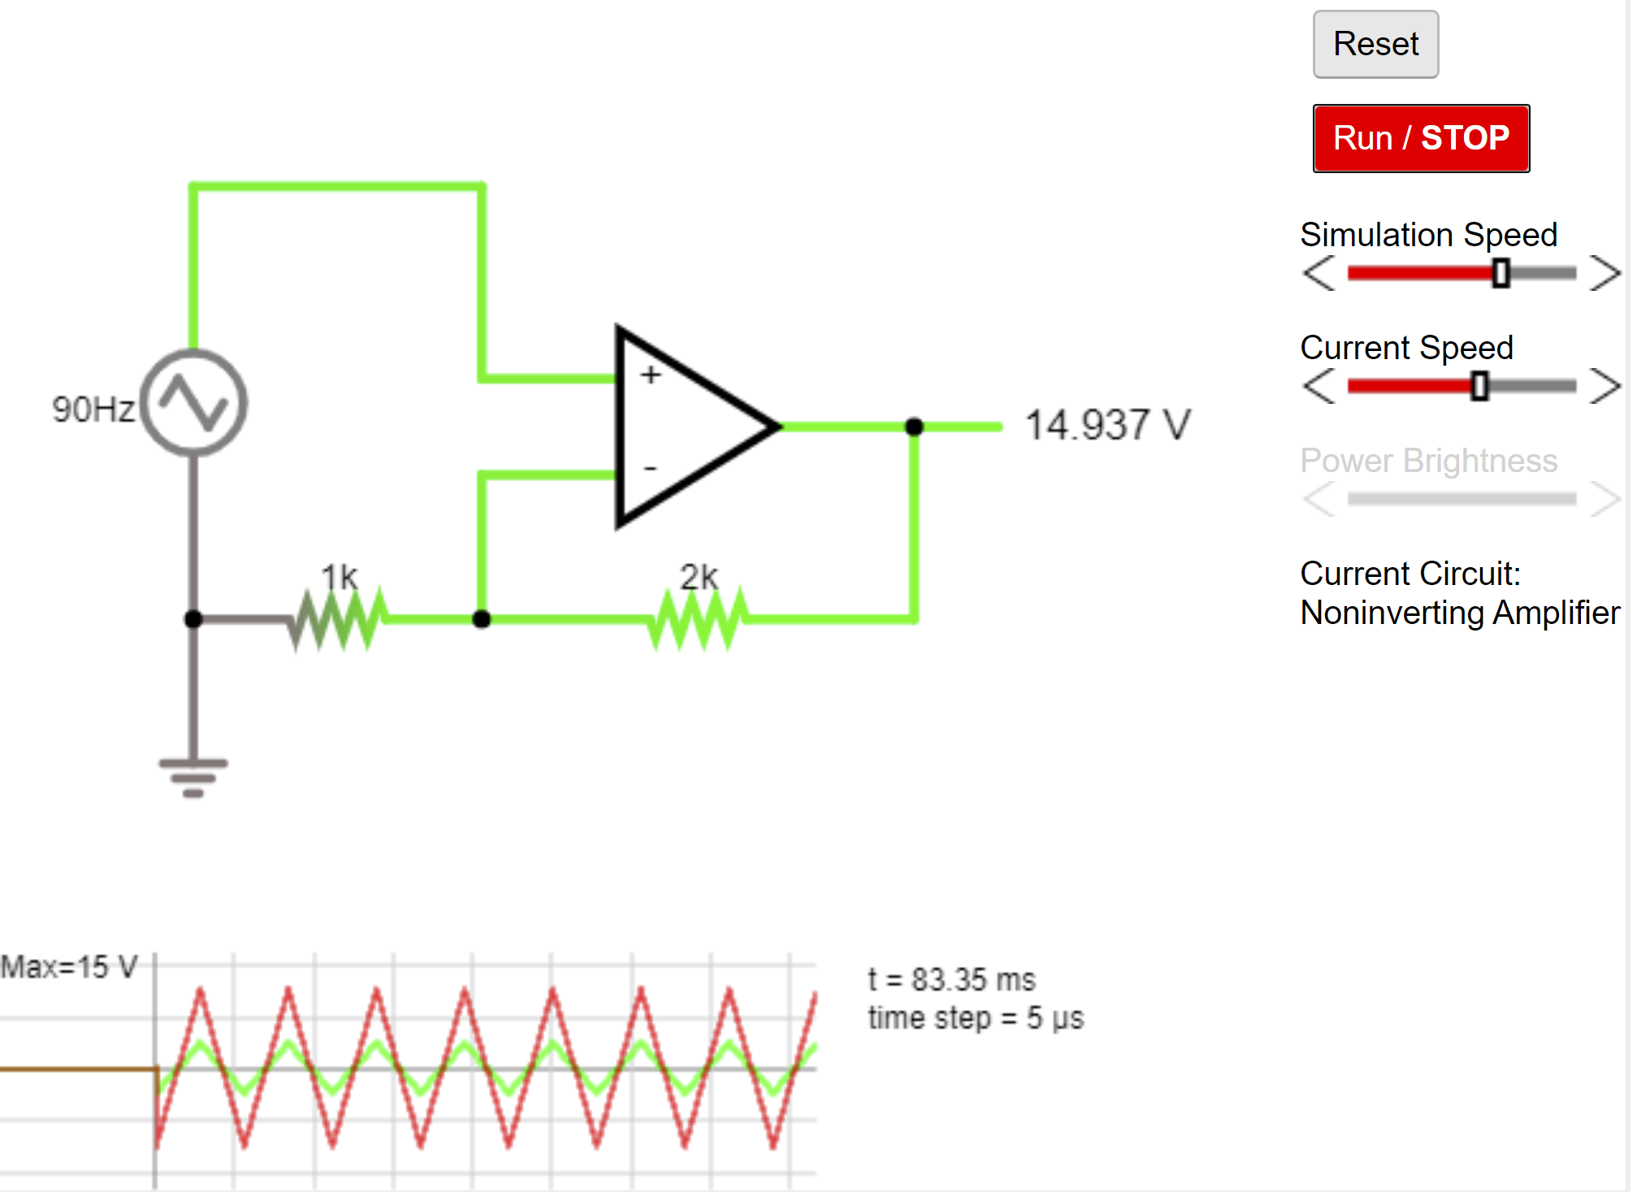

**Inverting Opamp**

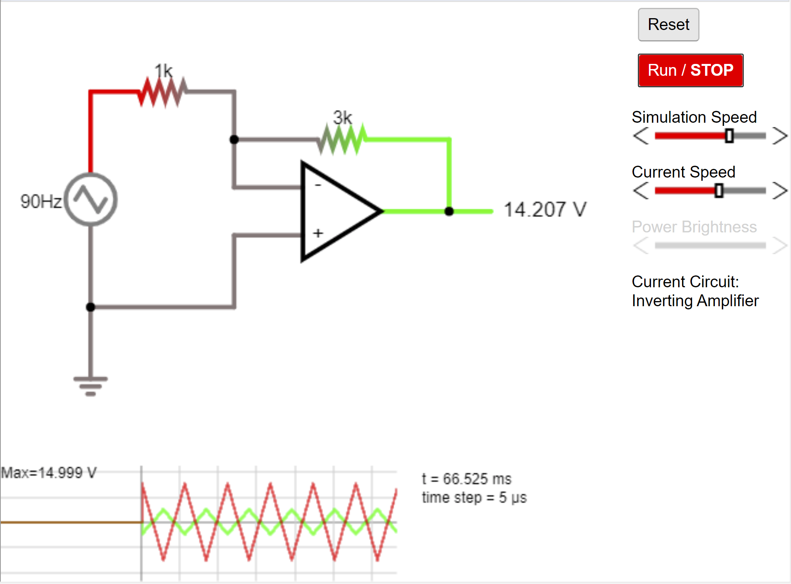

b) Sine wave :-

**Matlab**

Non Inverting OpAmp:

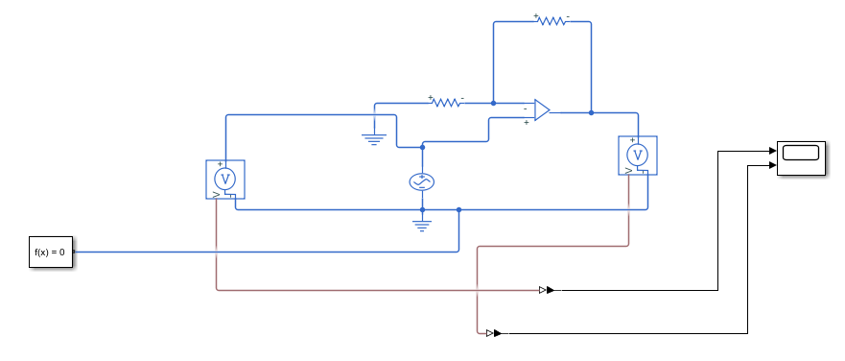

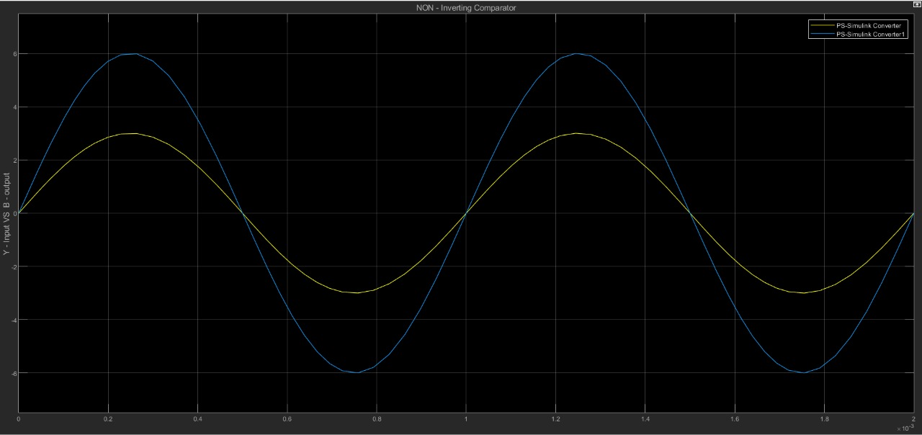

Inverting Op Amp :

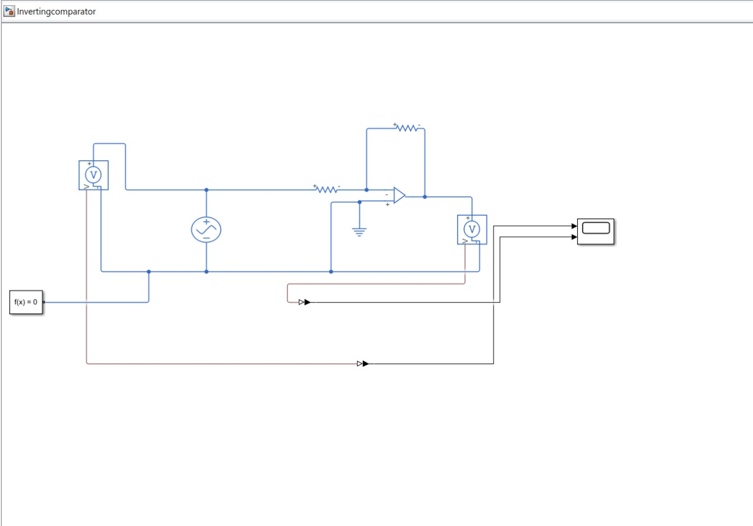

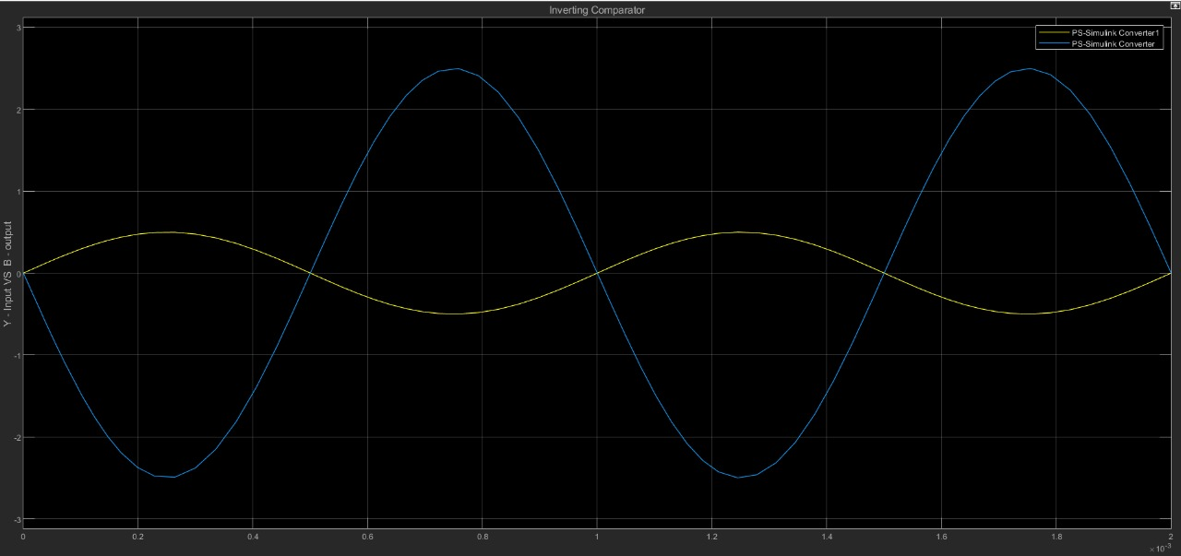

**Falstad**

**Inverting Opamp**

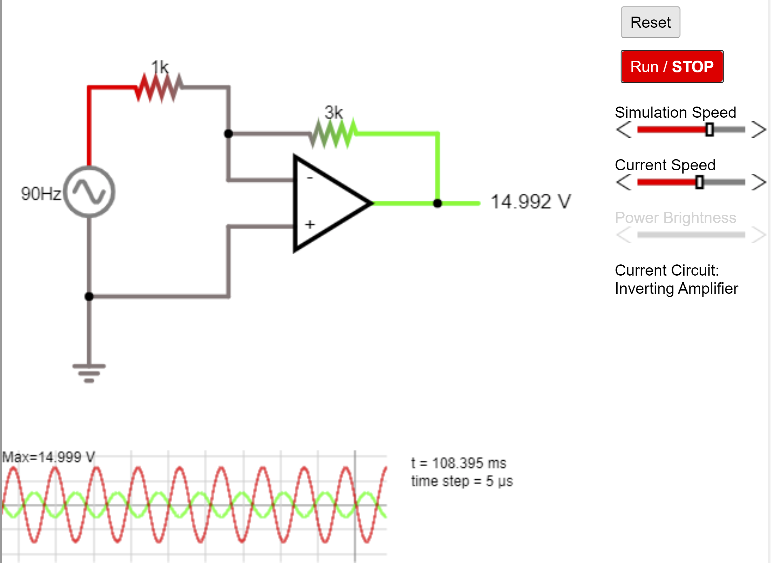

**Non Inverting OpAmp**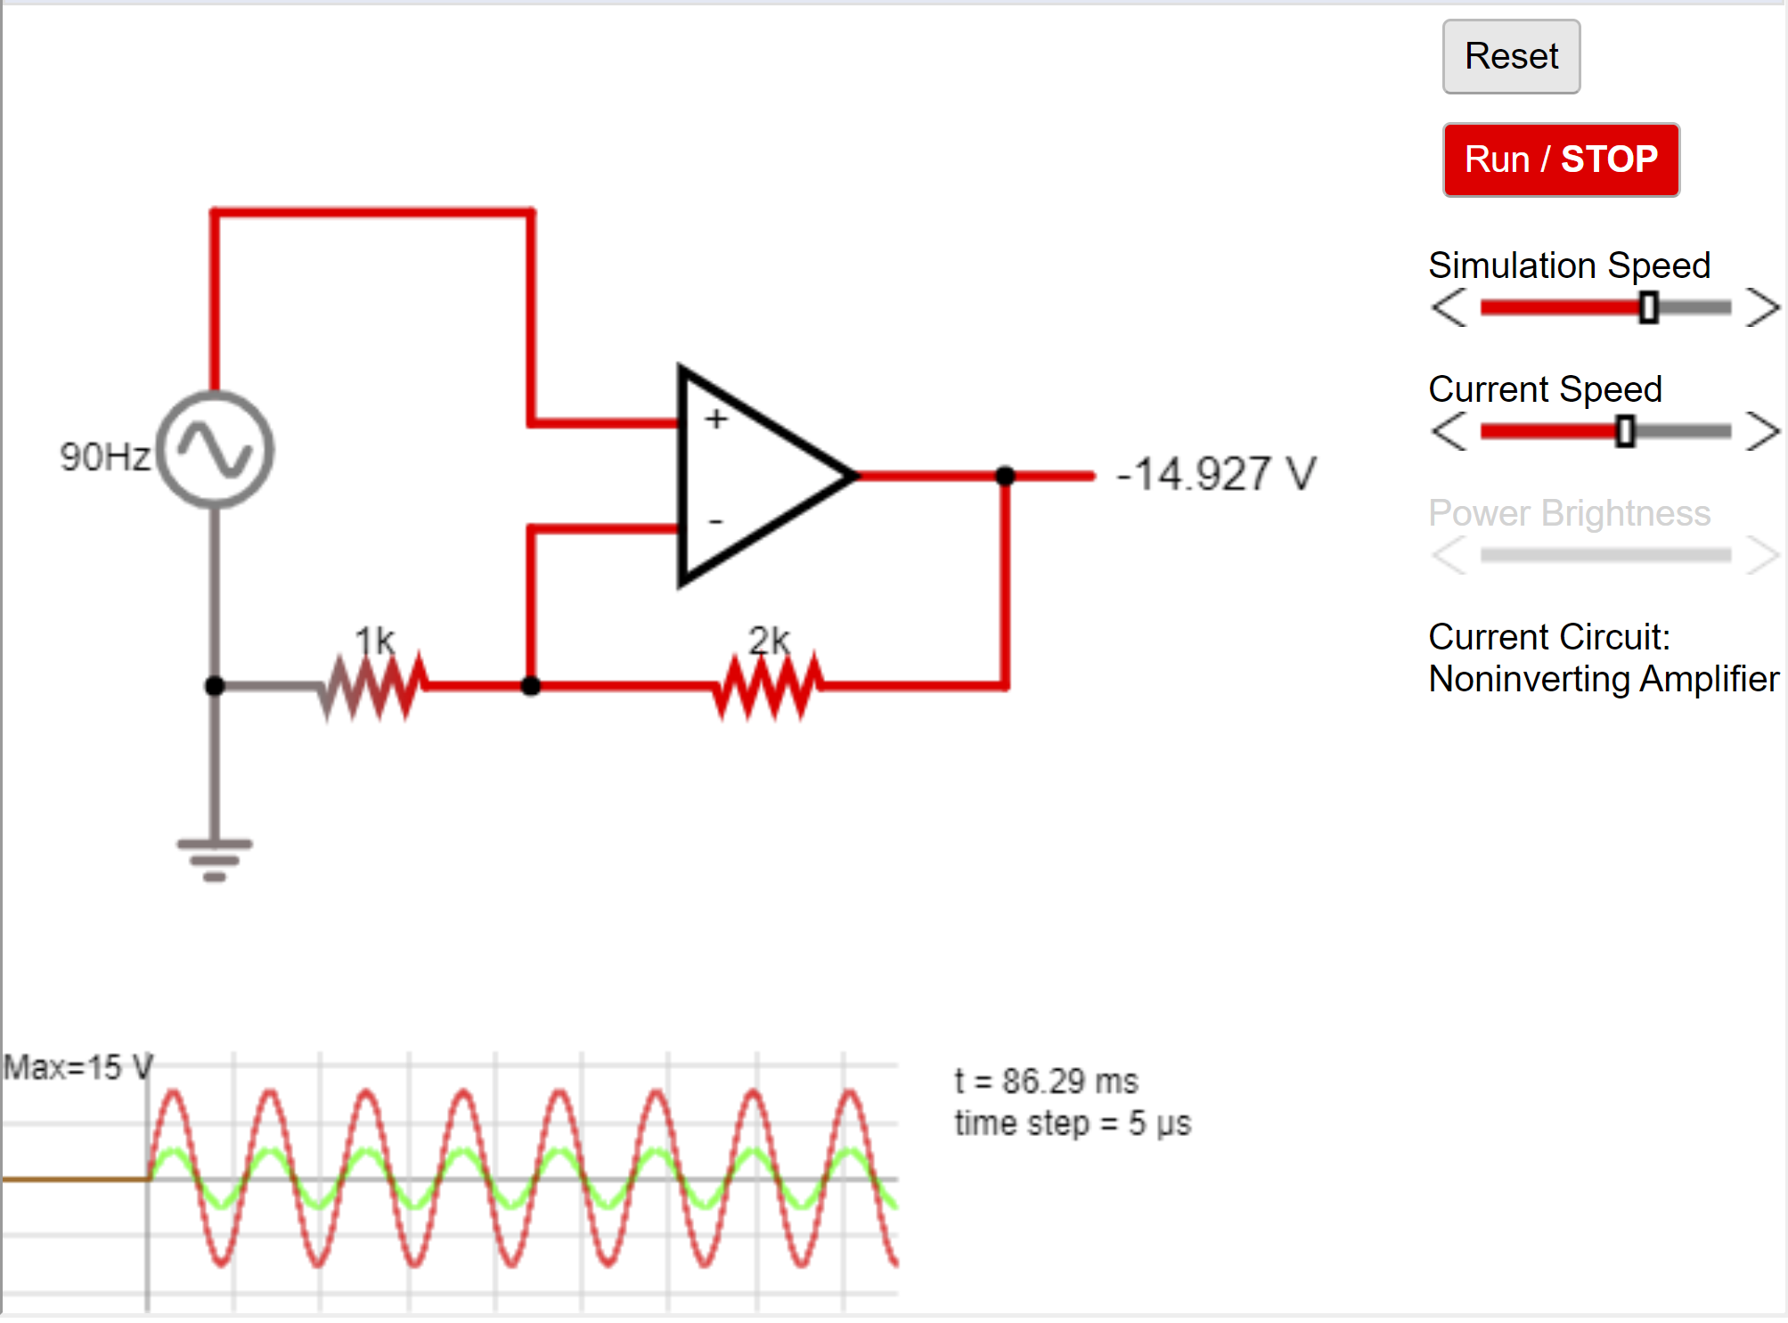

**INFERENCE:-**

* When input voltage is greater than reference voltage the output goes to + v saturation.
* When input voltage is less than reference voltage the output goes to -v saturation